**BUSINESS**: ***Creating informed, discerning employees, consumers and future leaders***

**Topic 1.5.1 Stakeholders**

**Key Vocabulary**

**Stakeholder –** anyone with an interest in the business

**Shareholder** – someone who owns part of a company (LTD or PLC)

**Employees** – people who work for your business

**Customer** – someone who buys from your business

**Manager** – someone with a position of responsibility within a business organisation

**Supplier** – someone or a business that provides stock or materials to a business

**Local community** – the people who live around the business

**Pressure group** – an organisation that will campaign for something specific, e.g. workers rights, environmental protection

**Government** – political power that can set laws and regulations that a business must follow

**Conflict** – when stakeholders groups do not want the same thing from a business

**Don’t be a “man on the street”**

* Don’t confuse stakeholders and shareholders
* Stakeholders are not one collective group
* Managers and owners are not the same thing
* Not all business owners are shareholders

**Core Knowledge**

Stakeholders are anyone interested in the activities of a business.

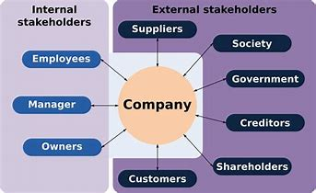

Each group is interested for different reasons, e.g. employees want to be paid a reasonable income and have job security.

Stakeholders are affected by business activity, e.g. local community is affected by the noise, pollution and traffic congestion, but may gain job opportunities or community sponsorship.

Each stakeholder group can influence a business, e.g. customers can write reviews of the business

Stakeholder groups may want different things and so there may be conflict between their needs. A business will need to manage this to try to satisfy as many stakeholder groups as possible.

**Wider Business World**

Plane Stupid is a pressure group that campaigns against increasing air travel

Greenpeace is a well known environmental pressure group

**Synoptic Links**

**Ownership** – sole traders and partnerships have owners / LTDs have shareholders

**Customer needs** – meeting these is important

**Ethical & environmental considerations** – pressure groups can influence these